**CARS- Regression Analysis**



The chosen dataset is a list of cars of different makes and models. The above table shows the sample data – car models and their attributes such as Type, Origin, Cylinders, etc.

On analyzing the data, it is seen that Horsepower, Length and Weight of a car affects its Mileage. Hence, MPG_Highway is the dependent variable and Horsepower, Weight and Length are the independent variables.

Multiple Regression Analysis is performed using Minitab to understand how the three independent variables affect the dependent variable.

Regression Equation: MPG_Highway = 41.14 – 0.01876 Horsepower – 0.005532 Weight + 0.0512 Length

Coefficient of Determination, R2 = 67.07% This means that 67.07% of variation in MPG_Highway is explained by variations in Horsepower, Length and Weight of the car.

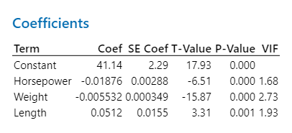

The p-value of all the terms in the regression equation is nearly 0. Significance level, α is 5%. Since p-value is less than α for all terms, we can conclude that there is a statistically significant association between the terms and the response variable.

Plots for the chosen data:

1. Normal Probability Plot: Since the points in this plot follow a straight line, the residuals are normally distributed. There are a few outliers in the plot.
2. Residuals Versus Order Plot: The residuals are randomly distributed about the center line with no trend or pattern, indicating that the residuals are independent from one another.
3. Residuals Versus Fits Plot: The points fall on both sides of 0 with no noticeable pattern, indicating that residuals are randomly distributed.
4. Histogram of Residuals: This shows and confirms that the residuals are normally distributed.

**Conclusion**: Using Multiple Regression Analysis, we conclude that there is a linear association between the chosen independent variables (Horsepower, Weight and Length) and the response/dependent variable (MPG_Highway).